|  |  |
| --- | --- |
| cetlogo ***CHEMICAL ENGINEERING TRANSACTIONS***  ***VOL. xxx, 2025*** | A publication of  aidiclogo_grande |
| The Italian Association  of Chemical Engineering  Online at www.cetjournal.it |
| Guest Editors: Fabrizio Bezzo, Flavio Manenti, Gabriele Pannocchia, Almerinda di Benedetto  Copyright © 2025, AIDIC Servizi S.r.l. **ISBN** 979-12-81206-17-5; **ISSN** 2283-9216 | |

Systematic Inherent safety assessment of electrolytic hydrogen production via NR-TOPSIS approach

Jing Danga, b, Zijian Dengc, Valerio Cozzani \* c, Yi Liu\* a, b

aState Key Laboratory of Chemical Safety, China University of Petroleum (East China), Qingdao 266580, China

bCollege of Chemistry and Chemical Engineering, China University of Petroleum (East China), Qingdao 266580, China

cDepartment of Civil, Chemical, Environmental and Materials Engineering, University of Bologna, Bologna,40131, Italy

corresponding. liuyi@upc.edu.cn

This study systematically collected 55 indicators related to hydrogen production via electrolysis and categorized them into 6 groups. An inherent safety assessment method based on the NR-TOPSIS approach was designed for indicator aggregation. In the first stage of indicator aggregation, inherent indicators were scored based on predefined evaluation criteria, standardized to unify dimensions, and positive and negative ideal solutions were determined. The distances between each indicator and the ideal solutions, as well as their relative proximity, were calculated to determine the importance of the indicators. In the second stage, a hierarchical structure was established, indicators were classified into different levels, and pairwise comparison matrices were constructed to assess the importance of the indicators. Judgment matrices were generated, and weight vectors were calculated, followed by consistency checks to ensure the rationality of the weight allocation. Finally, the results of indicator aggregation from both the first and second stages were integrated to obtain the final evaluation score for the system or scheme. Based on this, weight adjustment and sensitivity analysis were conducted to enhance the scientific validity and accuracy of the scores. By manually or automatically adjusting the weights, the impact of weight changes on the scoring results was tested, and the comparison matrices were iteratively optimized. The final adjusted weights were output, completing the entire feedback and optimization process, thereby achieving an inherent safety assessment of the safety of hydrogen production via electrolysis

* 1. Introduction

Inherent safety is a very important concept in the processes design. In industrial processes design, traditionally, techno-economic criteria were considered as the principal objectives in the early conceptual design. Safety was treated as a main objective in the detailed design stage (Park et al., 2020; Park, Pasman, & El-Halwagi, 2022). Hydrogen, as a new energy carrier with high potential, has received increasing attention in recent years. However, Hydrogen, as a highly hazardous gas, is of great significance for research on the inherent safety of its related hydrogen-related processes. Many research performed the risk assessment on the hydrogen related systems and established many inherent safety assessment approaches. But of all the approaches, selecting a suitable indicator which can correctly reflect the safety performance of the hydrogen-related systems is still a hard work. There are many studies to establish the methodologies of inherent safety. Gao presents a mechanistic framework for assessing and mitigating hydrogen leakage risks in Mobile Hydrogen Refuelling Stations (MHRS) based on inherent safety concepts. A bow-tie model is proposed to identify potential hazards, event pathways, and consequences(Gao *et al.*, 2024). Liu introduced a chemical reactive risk index (CRRI), filling the gap in pressure risk assessment. CRRI integrates a semiquantitative method based on risk analysis principles, consisting of the probability of reaction runaway and the severity of its consequences(Liu *et al.*, 2024). Gao introduced the inherent safety concept to minimize laboratory hazards and developed a dedicated implementation tool called Generic Laboratory Safety Metric (GLSM) which presented a set of generic solutions to laboratory retrofitting towards inherent safety with a novel GLSM as the implementation tool(Gao *et al.*, 2023). Norouzi introduces the Anticipated Inherent Risk Index (AIRI), a robust tool for rapid risk assessment of the worst anticipated scenarios. It incorporates Furthest Effect Distance of the release from the largest connection, by software, and Representative Failure frequency, which is a relative dataset calculated from renown databases (Norouzi, Baradaran and Sobati, 2024). Pu developed a Process Plant Healthiness Metric (PPHM) for generating holistic inherently healthier alternatives via the proposed Health Risk Management Framework (HRMF)(Pu, Raman, *et al.*, 2024). Qian proposed a semi-quantitative risk-based index, named the Inherent Process Risk Index (IPRI), is proposed to evaluate a process’s inherent safety from first principle chemical engineering calculations. The strategy proposed relies on simulation data from Aspen Plus and helps quantify the risk associated with both individual unit operation and the process (Qian, Vaddiraju and Khan, 2024). Deng established an inherent safety assessment framework to assess the on-board methanol reforming hydrogen fuel cell system (MRFC)’s inherent safety, considering jet fire and vapor cloud explosion (VCE) (Deng *et al.*, 2024). Pu developed a dedicated tool called Safety Metric for Plant Design (SMPD), integrating occupational safety and process safety aspects, to generate a holistic safer chemical plant via inherent safety oriented modifications (Pu, Abdul Raman, *et al.*, 2024). All these approaches have proposed many indicators to reflect the performance of chemical processes’ inherent safety. Since it’s necessary to select a suitable indicator to reflect the inherent safety level of hydrogen-related systems.

However, the traditional TOPSIS method is deficient in dealing with the interdependence between indicators and the subjectivity of weight assignment. To overcome these problems, (Buchmayr *et al.*, 2023) proposed the NR-TOPSIS (Normalized Rank-TOPSIS) method, which dramatically improves the stability and accuracy of the assessment results by constructing a hierarchical structure and normalized ranking. The NR-TOPSIS method is able to effectively combine expert judgments and objective data, which is particularly suitable for multilevel and multi-indicator inherent security assessment. Although the NR-TOPSIS method has been successfully applied in other fields, it is the first time that it has been applied to assess the intrinsic safety of electrolytic hydrogen production systems. This study aims to fill this research gap by evaluating the applicability and effectiveness of the NR-TOPSIS methodology in the evaluation of the intrinsic safety of hydrogen electrolysis production. Specifically, the NR-TOPSIS method has the following obvious advantages: Hierarchical structure treatment: effectively manages the complex, multilevel safety indicator system in the production of water electrolyzed hydrogen. Comprehensive weighting method: Combining expert opinion and objective data to ensure the scientificity and reliability of weight allocation. Enhanced Stability: Reduces sorting instability caused by differences in indicator scales through normalization, ensuring consistent and reliable assessment results. Clarity of Decision Support: Clear risk ranking and decision support to effectively identify and mitigate key risks. By clearly articulating the motivation and methodological advantages of the research, this study is of great significance to the inherent safety assessment methodology of hydrogen electrolysis production.

* 1. Methodology

This approach provides a method for assessing the safety of electrolytic hydrogen production systems.

* + 1. Two-layer indicator collection

Based on chemical process safety evaluation theories, we systematically selected 55 indicators relevant to electrolytic hydrogen production and grouped them into 6 categories: material properties, process conditions, reaction characteristics, equipment properties, activity types, and accident consequences.

* + 1. First-layer indicator aggregation

First, the intrinsic indicators are scored. Based on predefined evaluation criteria, an initial score is assigned to each indicator. Subsequently, these scores are normalized to convert indicators with different dimensions into a unified scale. Next, the positive ideal solution and the negative ideal solution are determined, representing the optimal and worst values of the indicators, respectively. Then, the distances between each indicator and the positive and negative ideal solutions are calculated to quantify the extent to which the indicators approach the optimal or worst values. Finally, these distances are used to compute the relative closeness of each indicator, thereby determining the relative importance of each indicator.

* + 1. Second-layer indicator aggregation

The second phase involves establishing a hierarchical structure, categorizing all indicators into different levels, constructing pairwise comparison matrices to assess the relative importance of the indicators, and generating judgment matrices. Further calculations yield the weight vectors for each indicator, followed by a consistency check to ensure the consistency between the weight allocation and the judgment matrix. After the weight calculation is completed, the results of the primary and secondary indicators are synthesized to derive the final comprehensive score.

* 1. Discussion
     1. Initial data collection

Systematic scoring criteria as Table 1, and Table 2 presents the ratings for the safety, operational complexity, equipment requirements, and potential consequences of accidents associated with electrolytic technologies, providing a foundational basis for systematic risk assessment.

*Table 1 Systematic scoring criteria*

|  |  |  |  |  |  |
| --- | --- | --- | --- | --- | --- |
| Scoring criteria | 1 | 2~3 | 4~6 | 7~8 | 9~10 |
| Description | Very low (very ideal) | Low (ideal) | Medium (acceptable risk or performance) | High (poor, close to non-ideal) | Very high (very undesirable) |

*Table 2 Systematic Scoring and Weighting of Electrolysis Technology*

| Category of Indicators | Score | Description | Weight | Description |
| --- | --- | --- | --- | --- |
| Properties | | | | |
| Flammability | 8 | Hydrogen accumulation risk | 5% | Highly flammable |
| Explosiveness | 9 | High-voltage sparks risk | 5% | - |
| Toxicity | 5 | Potential toxic releases | 3% | Explosion risk high |
| Corrosiveness | 7 | Corrosive electrolyte | 3% | - |
| Volatility | 4 | Electrolyte evaporation risk | 2% | Minor toxic risks |
| State of material | 4 | Leakage-prone electrolyte | 2% | - |
| Volume change | 5 | Limited electrolyte volume change | 2% | Equipment corrosion |
| Solubility | 6 | High electrolyte solubility | 2% | - |
| Ability to precipitate | 4 | Electrolyte precipitation risk | 2% | Environmental risk |
| Density difference | 4 | Affects efficiency and consumption | 2% | - |
| Viscosity | 3 | Viscosity changes | 2% | Minimal safety impact |
| Relative density | 3 | Slight density difference | 2% | Minor safety impact |
| Molecular weight | 2 | Small molecular weight impact | 2% | Operational impact |
| Hazardous substances | 6 | Harmful electrolyte components | 3% | Recycling concerns |
| Process | | | | |
| Temperature | 7 | High-temp operational requirement | 4% | Minor separation impact |
| Pressure | 8 | High-pressure operation | 4% | Minor fluidity impact |
| Production | 9 | High hydrogen production rate | 6% | Minor design impact |
| Inventory | 8 | Hydrogen and electrolyte storage | 4% | Stability concern |
| Process mode | 4 | Continuous process | 3% | Environmental concerns |
| Flow rate | 5 | Stable flow requirement | 3% | Temp control risk |
| Concentration | 7 | Precise control needed | 3% | Explosion risk |
| Level | 6 | Electrolyte level variability | 3% | Efficiency impact |
| pH | 5 | Strict pH control required | 3% | Leakage risk |
| Flowability | 4 | Fluidity variation | 2% | Stability impact |
| Type of unit operation | 5 | Multiple process components | 3% | Efficiency concerns |
| Reaction | | | | |
| Chemical interaction | 8 | Complex electrode interactions | 4% | Control needed |
| Heat of primary reaction | 7 | High heat generation | 4% | Operation impact |
| Heat of secondary reaction | 8 | High voltage side-reactions | 3% | Stability concerns |
| Reaction type | 7 | Complex electrochemical reaction | 3% | Minimal fluidity impact |
| Runaway reaction | 9 | High uncontrolled reaction risk | 5% | Safety control crucial |
| Equipment | | | | |
| OSBL | 6 | Explosion-proof devices needed | 3% | Stability impact |
| ISBL | 7 | Large-scale equipment | 3% | Temp control essential |
| Structure | 7 | Complex equipment maintenance | 4% | Side reaction heat |
| Layout | 6 | Strict arrangement needed | 3% | Complexity impact |
| Complexity | 8 | High operational complexity | 4% | Uncontrolled reaction risk |
| Type of equipment | 6 | Various equipment involved | 3% | Control ease |
| Safety devices | 7 | Explosion-proof equipment required | 3% | Layout influence |
| Emission rate of equipment | 8 | High hydrogen emissions | 3% | Operational difficulty |
| Activities | | | | |
| Transportation | 5 | Leakage prevention necessary | 3% | Explosion-proof layout |
| Emission or combustion | 9 | High hydrogen output | 4% | Additional safety measures |
| Maintenance | 8 | Complex equipment maintenance | 3% | Control requirements |
| Other | 4 | Regular electrolyte replacement | 2% | Testing needed |
| Consequence | | | | |
| Fireball | 9 | Fireball risk from leakage | 5% | Strict emission control |
| Jet fire | 8 | High-temperature leak fire risk | 4% | Transportation risk |
| Pool fire | 7 | Leak onto hot surfaces risk | 3% | Combustion control |
| VCES | 8 | Vapor cloud explosion risk | 4% | Maintenance complexity |
| BLEVE | 9 | Pressurized hydrogen BLEVE risk | 5% | Minor stability impact |
| Enclosed | 8 | High-sealing requirements | 3% | Fireball risk |
| Spread of toxic chemicals | 7 | Toxic component leak risk | 4% | Jet fire risk |

* + 1. First-layer indicator

Figure 1 illustrates the relative proximity (closeness) of the electrolytic hydrogen production system on different indicator dimensions. According to the NR-TOPSIS methodology, the distance of each indicator is calculated relative to the ideal (best) scenario and the non-ideal (worst) scenario. The results in the figure clearly reflect the extent to which each category of metrics contributes to the inherent safety of the system. For example, Reaction and Equipment are likely to have a high relative importance, implying that these two categories have a significant impact on the overall inherent safety in an electrolytic hydrogen production system. This also implies that more attention should be paid to the improvement and optimization of Reaction and Equipment in practical safety management and process design.

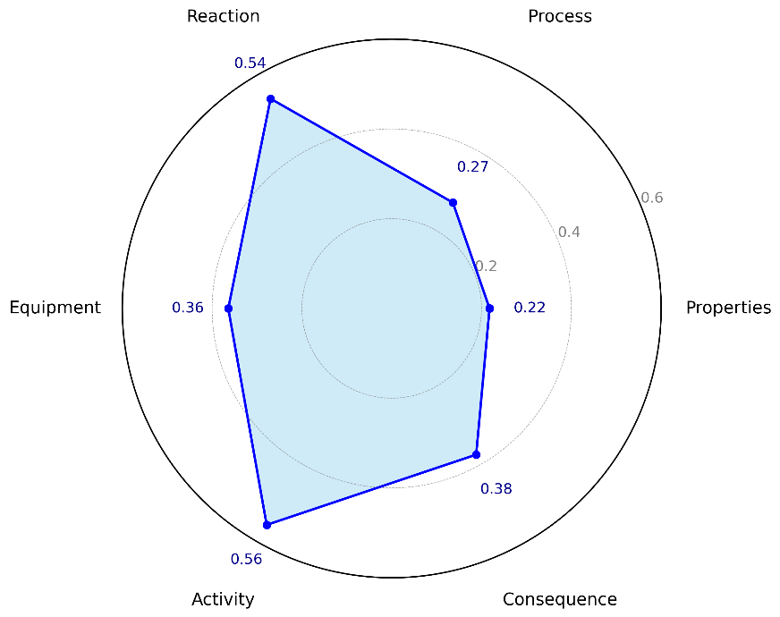

*Figure 1: electrocatalysis closeness across dimensions*

* + 1. Second-layer indicator

Table 3 shows the weighting matrix for the Level 2 indicators, where expert judgment was used to form a pairwise comparison matrix to determine the relative importance of each category. For example, the high importance of Consequences relative to the other indicator categories (e.g., nature of substance, process, reaction, equipment, activity) reflects the general consensus that the consequences of accidents are an area of particular emphasis when assessing the inherent safety of hydrogen electrolysis. The matrix provides a numerical visualization of the weighting relationships between the different categories of indicators, providing a clear reference for decision makers.

Table 4 demonstrates the consistency check performed on the above weight assignment matrix. By calculating the eigenvalue (λ\_max), consistency index (CI) and consistency ratio (CR), it is shown that the formulated weight matrix possesses good internal logical consistency (CR = 0.05 < 0.1), indicating that the expert judgment and weight setting are reasonable and credible. This consistency test ensures the robustness of the whole safety evaluation system and the reliability of the assessment results, which can effectively support further decision-making and optimization of risk control measures.

The final inherent safety score of 0.433 for electrolytic hydrogen production indicates that the system possesses a moderate level of inherent safety. This value, which ranges between 0 (extremely unsafe) and 1 (extremely safe), suggests that while certain safety measures are effectively in place, there are significant areas for improvement. Specifically, the moderate score highlights the need for enhanced safety management in critical aspects such as equipment protection, process control, and emergency response. The score serves as a diagnostic tool, providing insights into the system's relative safety performance and identifying key areas where additional safeguards are necessary. Moreover, this score can be used as a benchmark for comparing the inherent safety of different hydrogen production systems or similar processes in other industries. Regular monitoring of this score over time can further support continuous improvement initiatives, ensuring that safety measures are systematically enhanced.

Table 3: Weight scoring of the second-level indicators

|  |  |  |  |  |  |  |
| --- | --- | --- | --- | --- | --- | --- |
| Indicator category | properties | Process | Reaction | Equipment | Activity | consequences |
| properties | 1 | 1/3 | 1/5 | 1/4 | 1/3 | 1/6 |
| Process | 3 | 1 | 1/3 | 1/2 | 1 | 1/4 |
| Reaction | 5 | 3 | 1 | 3 | 2 | 1/2 |
| Equipment | 4 | 2 | 1/3 | 1 | 1/2 | 1/3 |
| Activity | 3 | 1 | 1/2 | 2 | 1 | 1/3 |
| consequences | 6 | 4 | 2 | 3 | 3 | 1 |

Table 4: Verification of scoring weights

|  |  |  |  |  |  |  |  |  |
| --- | --- | --- | --- | --- | --- | --- | --- | --- |
| Column sum | 22.00 | 11.33 | 4.37 | 9.75 | 7.83 | 2.58 | Weight | Weight Ratio |
| Normalized matrix | 0.0455 | 0.0294 | 0.0458 | 0.0256 | 0.0426 | 0.0645 | 0.0422 | 0.261 |
| 0.1364 | 0.0882 | 0.0763 | 0.0513 | 0.1277 | 0.0968 | 0.0961 | 0.593 |
| 0.2273 | 0.2647 | 0.2290 | 0.3077 | 0.2553 | 0.2568 | 0.2568 | 1.568 |
| 0.1818 | 0.1765 | 0.0763 | 0.1026 | 0.0638 | 0.1290 | 0.1217 | 0.755 |
| 0.1364 | 0.0882 | 0.1145 | 0.2051 | 0.1277 | 0.1290 | 0.1335 | 0.848 |
| 0.2727 | 0.3529 | 0.4580 | 0.3077 | 0.3830 | 0.3871 | 0.3602 | 2.277 |
|  | λ\_max | 6.30 |  | CI | 0.06 |  | CR | 0.05 |

* + 1. Indicator Weight Adjustment

Based on *Tables 2 and 4*, we adjusted the weights again and observed their sensitivity performance. Figure 2 shows the extent to which the adjustment of the weights of each indicator category affects the overall safety evaluation results as observed through the sensitivity analysis. It is clear from the figure that changes in the weights of the three indicator categories Equipment, Reaction and Process have a greater impact on the intrinsic safety score, whereas changes in Properties, Activity and Consequences have a smaller impact. This suggests that we should be careful when assigning weights. This suggests that when assigning weights, priority should be given to ensuring an accurate assessment of the weights of the equipment, reaction and process conditions indicators, as their weighting has a significant impact on the safety evaluation of the system.

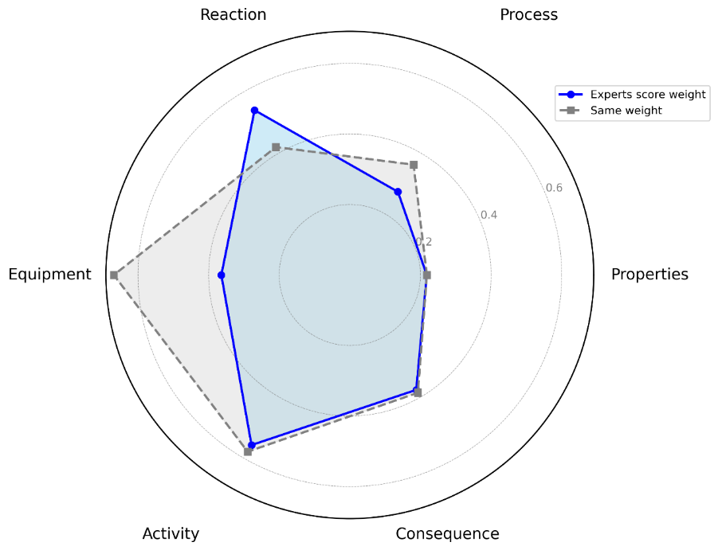

*Figure 2: electrocatalysis closeness across dimensions*

* 1. Conclusions

The inherent safety score for hydrogen production via water electrolysis, calculated based on the final weights of secondary indicators, is 0.433. Sensitivity analysis indicates that changes in weights have the least impact on physical properties, activity, and consequences, while having the greatest impact on equipment, followed by reactions and processes. This finding underscores the critical importance of selecting weights for equipment, reactions, and processes in the assessment of inherent safety for hydrogen production via water electrolysis.

This framework reveals the inherent safety performance of hydrogen electrolysis production, which can be used to guide safety improvements and promote technological advancement.

References

Buchmayr, A., et al., 2023, A distance-to-sustainability-target approach for indicator aggregation and its application for the comparison of wind energy alternatives, \*Renewable and Sustainable Energy Reviews, 185,\* 113608.

Deng, Z., et al., 2024, Inherent safety assessment of on-board methanol reforming hydrogen production fuel cell system considering jet fire and vapor cloud explosion, \*International Journal of Hydrogen Energy, 50,\* 1047–1061.

Gao, X., et al., 2023, Bayesian networks based laboratory retrofitting towards inherent safety: A risk-based implementation framework, \*Journal of Loss Prevention in the Process Industries, 83,\* 105036.

Gao, X., et al., 2024, A mechanistic framework for the leakage risk reduction of mobile hydrogen refueling stations based on inherent safety concepts, \*International Journal of Hydrogen Energy, 83,\* 1370–1384.

Liu, Z., et al., 2024, A novel inherent safety index for reactive hazard evaluation integrating thermal and pressure effects, \*Process Safety and Environmental Protection, 187,\* 1586–1595.

Norouzi, H., Baradaran, S., & Sobati, M.A., 2024, Developing a novel anticipated inherent risk assessment approach applicable in early stages of process design, \*Process Safety and Environmental Protection, 191,\* 2165–2177.

Park, S., et al., 2020, Incorporating inherent safety during the conceptual process design stage: A literature review, \*Journal of Loss Prevention in the Process Industries, 63,\* 104040.

Park, S., Pasman, H. J., & El-Halwagi, M. M., 2022, Progress in Inherently Safer Design for Chemical Processes, Chemical Engineering Transactions, 90, 463–468.

Pu, W., Raman, A.A.A., et al., 2024, Development of comprehensive healthier process plants based on inherent safety concept, \*Process Safety and Environmental Protection, 184,\* 804–822.

Pu, W., Abdul Raman, A.A., et al., 2024, Process & occupational safety integrated inherently safer chemical plant design: Framework development and validation, \*Journal of Loss Prevention in the Process Industries, 87,\* 105204.

Qian, Y., Vaddiraju, S., & Khan, F., 2024, Inherent Process Risk Index (IPRI) – A tool for analyzing inherently safer design using Aspen Plus simulation, \*Process Safety and Environmental Protection, 183,\* 399–416.